**Assignment – 2**

Answer 1:

When generating books for our experiment we vary the following parameters: Author, title and ISBN. The author and titles are random strings of alphabetic characters with fixed length and the ISBNs are numerically increasing from 1. Depending on the data structure that keeps the books, the fact that ISBNs are not distributed realistically might impact performance, but most implementations will use some form of map or hashing that will make this irrelevant. Still, it should be kept in mind that this might negatively impact the predictions of our metrics. Another reasonable strategy for ISBN generation is simply to pick a uniformly random positive integer. Even better, a large amount of real ISBNs could be used as a source.

Our experiments were run on a single machine with an Intel Core i5-3337U processer. It has 2 cores each capable of running 4 threads. The processor has 3MB of cache shared between threads. The machine has 8GB of RAM and runs 64-bit Windows 10.

We do our measuring for varying number of concurrent clients accessing the bookstore. We don’t do multiple experiments for the same number of clients, so we can’t apply any statistical methods to it.

**Answer No 2:**

Here is the graphs for our experiments:

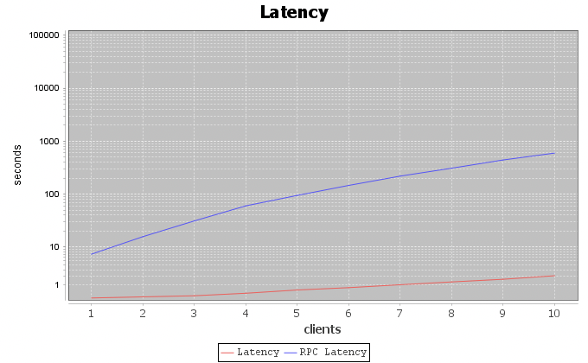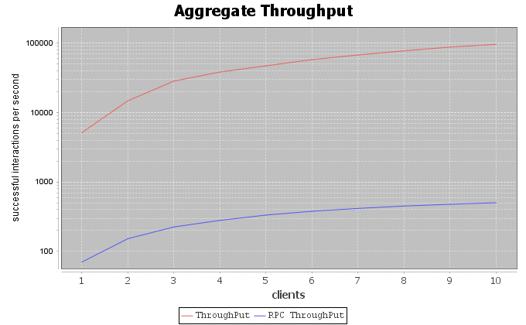

The first obvious trend to notice is that the local computations are faster than the re- mote ones by orders of magnitude. This matches our expectations, since RPCs have the entire overhead of transferring the data through HTTP.

Another thing to notice is that throughput increases as we add concurrent clients. We are testing against the basic bookstore implementation with no concurrency control at all, so every thread can access any data at all times. That throughput increases is then expected because we take advantage of the multiple processor threads.

In the case of RPC throughput, we expect that the throughput gain comes from the se- rialization and sending of data being parallelized, since the actual bookstore operations happen on the single-threaded server. In this case though, the serverside computations are all relatively cheap, so they do not dominate performance.

When clients increase, so does the latency for each client, especially in the case of RPCs. In the case of local computation access to resources get more frequent and should impact performance. In the case of RPC latency, the server needs to respond to all requests, which also impacts performance.

**Answer 3:**

In order to evaluate how well our metrics should predict the actual performance of the system, we need to look at how our metrics have been chosen. In this case, by the distribution of tasks, we have strived to simulate what we believe to be an average workload. We deliberately generate buy orders of less than 10 books and similarly add small sets of books.

Obviously, we don’t actually know that the workload is realistic., In a real life scenario, we would probably use some form of logging during normal operation and using the log to inform our workload generation. For this case though, we believe the strategy is good. It should produce metrics close to the actual service performance.

However, the strategy does not test for abnormal workloads at all. For example, a big release could prompt a large spike in users trying to buy the exact same book, or a number of clients could put in huge buy orders of many different books which might similarly stress the system.

In order to effectively test for these cases, some amonut of foresight must be involved. For example, if we anticipate a big release, we should test the service against the abnormal workload that we expect will occur.